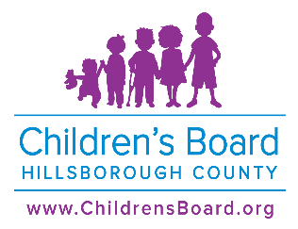
fY2025 PROVIDER DISASTER verification fORM AND CONTACT information
(pLEASE PRINT or type)
Purpose: To identify the point of contact to determine operational status of the CBHC funded services.
Pursuant to Section 29 of the General Terms and Conditions of the contract: The PROVIDER will submit to the CHILDREN'S BOARD a PROVIDER Disaster Verification Form within thirty (30) days of receiving an executed contract which attests that an Emergency Services Work Plan is in place and up to date.
Agency Name: | DATE:
Name of Person Completing Form: | Title of Person Completing Form:
Primary Agency Disaster Contact Name: | Cell Phone Number (Include area code.)  Text message capable? YES NO (circle one)
Primary Agency Disaster Contact Email Address: | Primary Agency Disaster Contact Landline:
Secondary Agency Disaster Contact Name: | Cell Phone Number (Include area code.)  Text message capable? YES NO (circle one)
Back up Agency Disaster Contact Email Address: | Back up Agency Disaster Contact Landline:
Agency Disaster Plan in effect and up to date at start of fiscal year? (Check appropriate.)  Yes ______ No______ | If no, what is the status of Disaster Plan development?  Not started______ Draft Plan_______
Agency & Program Address Location(s) in Hillsborough County: (Include administrative offices & other CBHC funded program operating sites: | Program Name & Site Address:
Program Name & Site Address: | Program Name & Site Address:
Program Name & Site Address: | Program Name & Site Address:

In the event that the agency/program being funded by the Children’s Board is negatively impacted by a disaster please notify the following:

● Maria Negron, Children’s Board Program Director of Programs at (813) 204-1795 or negronma@childrensboard.org
● Call 2-1-1 or log onto www.211atyourfingertips.org to update your profile

